**Assignment 1: Banking Application**

**Case 1: (Open an Account) (Starting from 1 -> 2)**

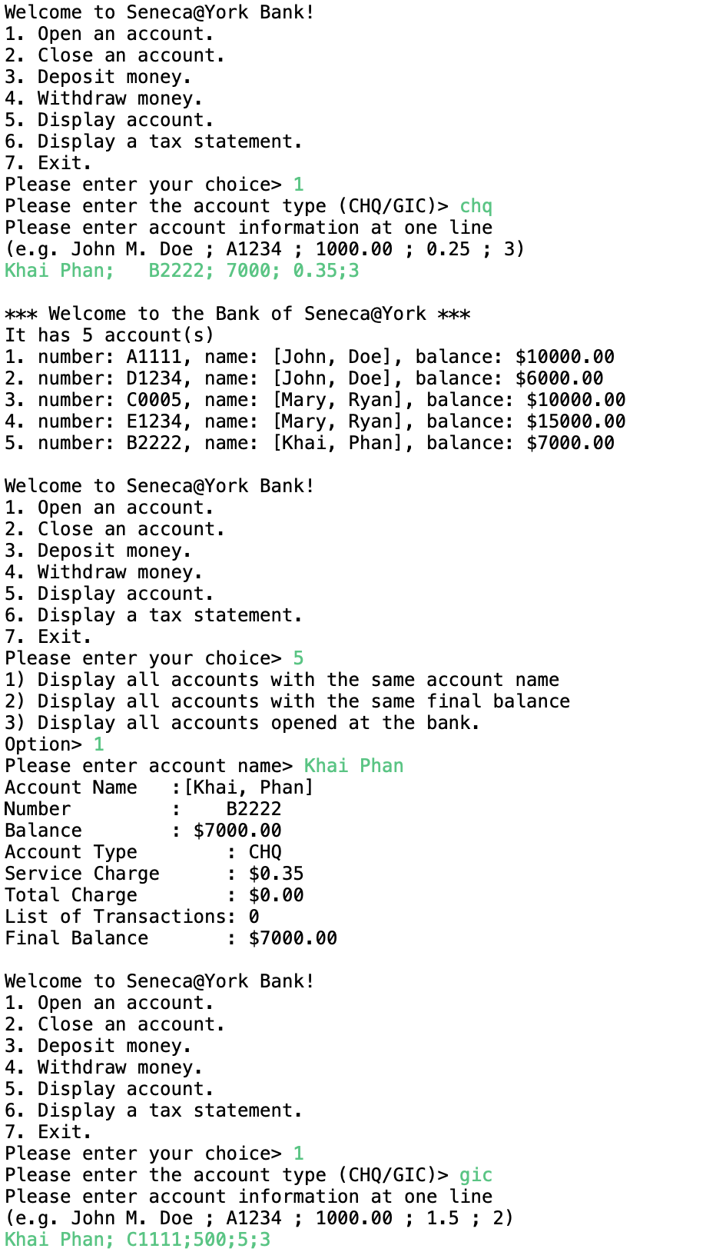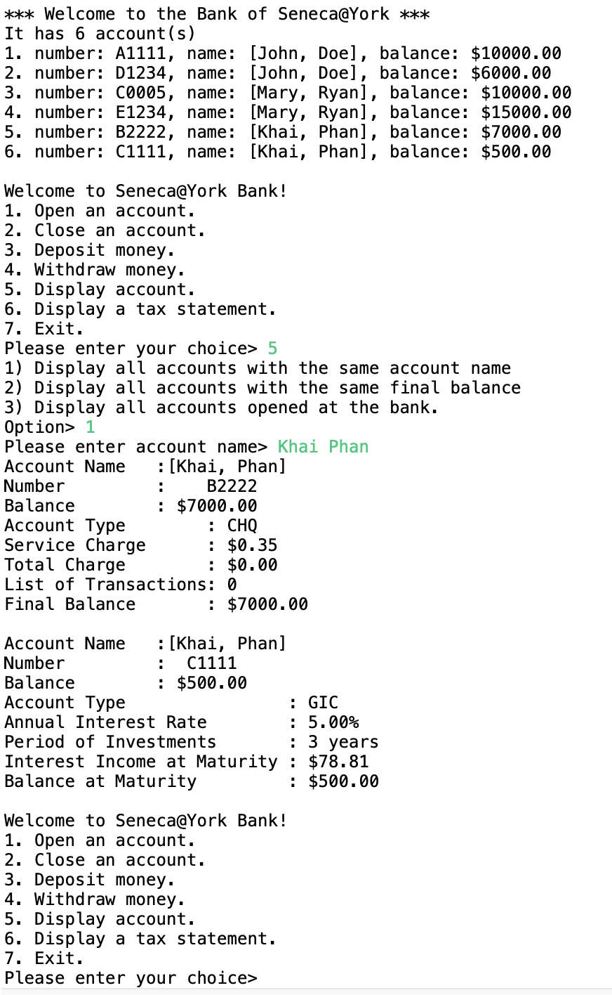

**Case 2: (Close an Account) (Starting from 1 -> 2)**

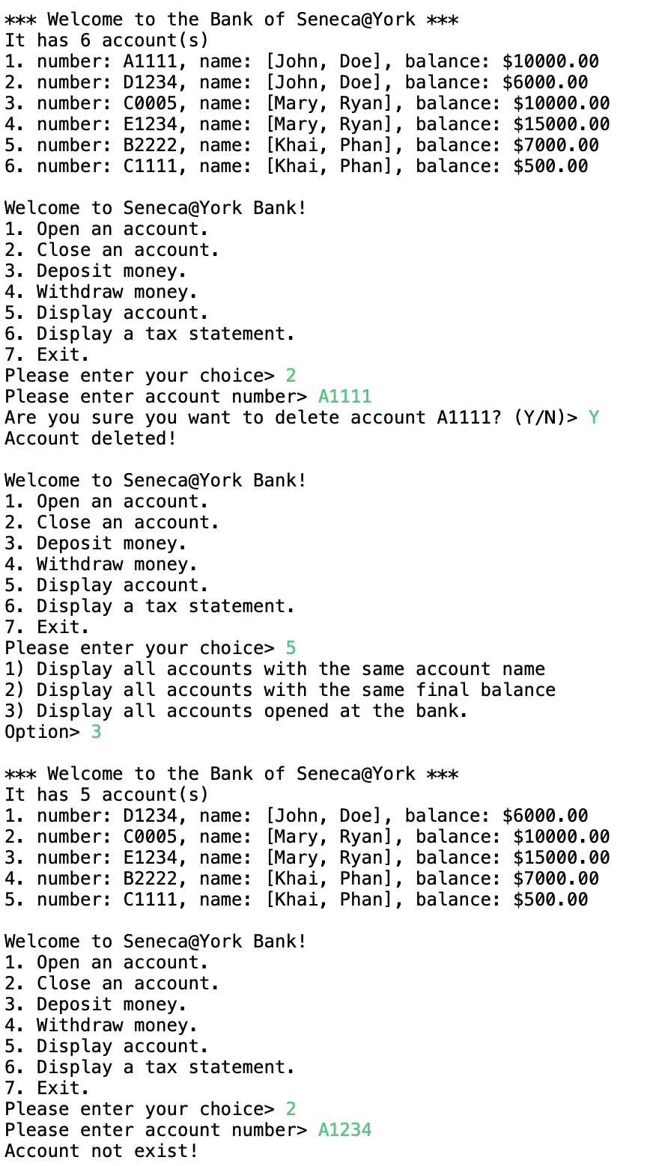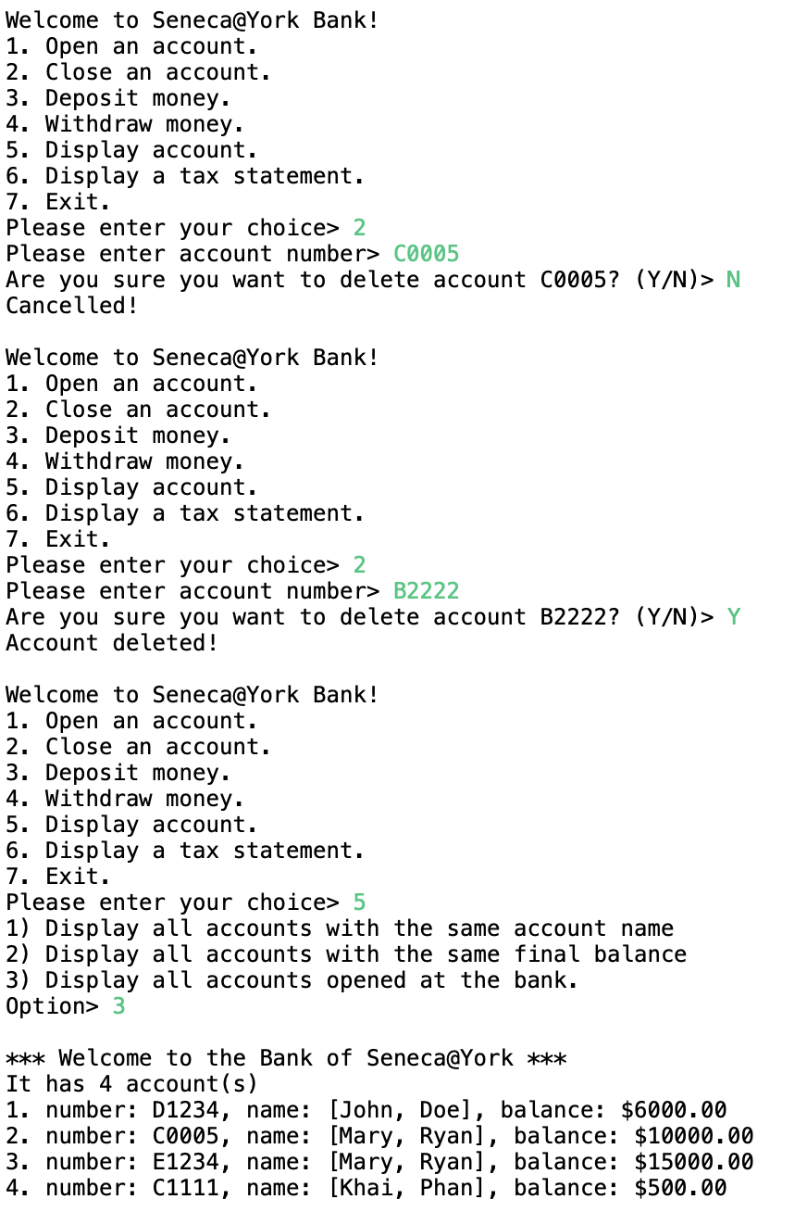

**Case 3: (Deposit Money) (Starting from 1 -> 2)**

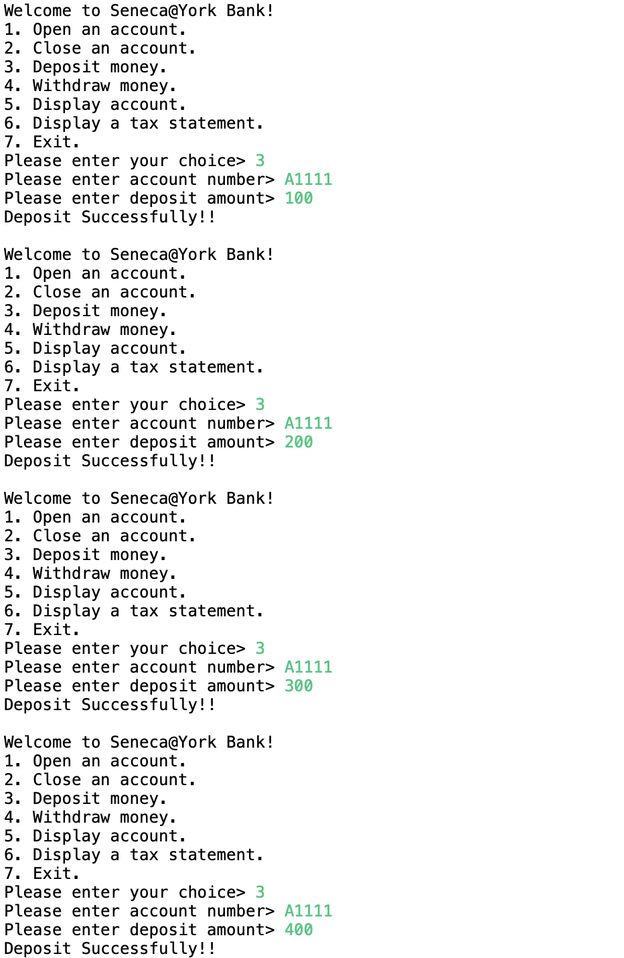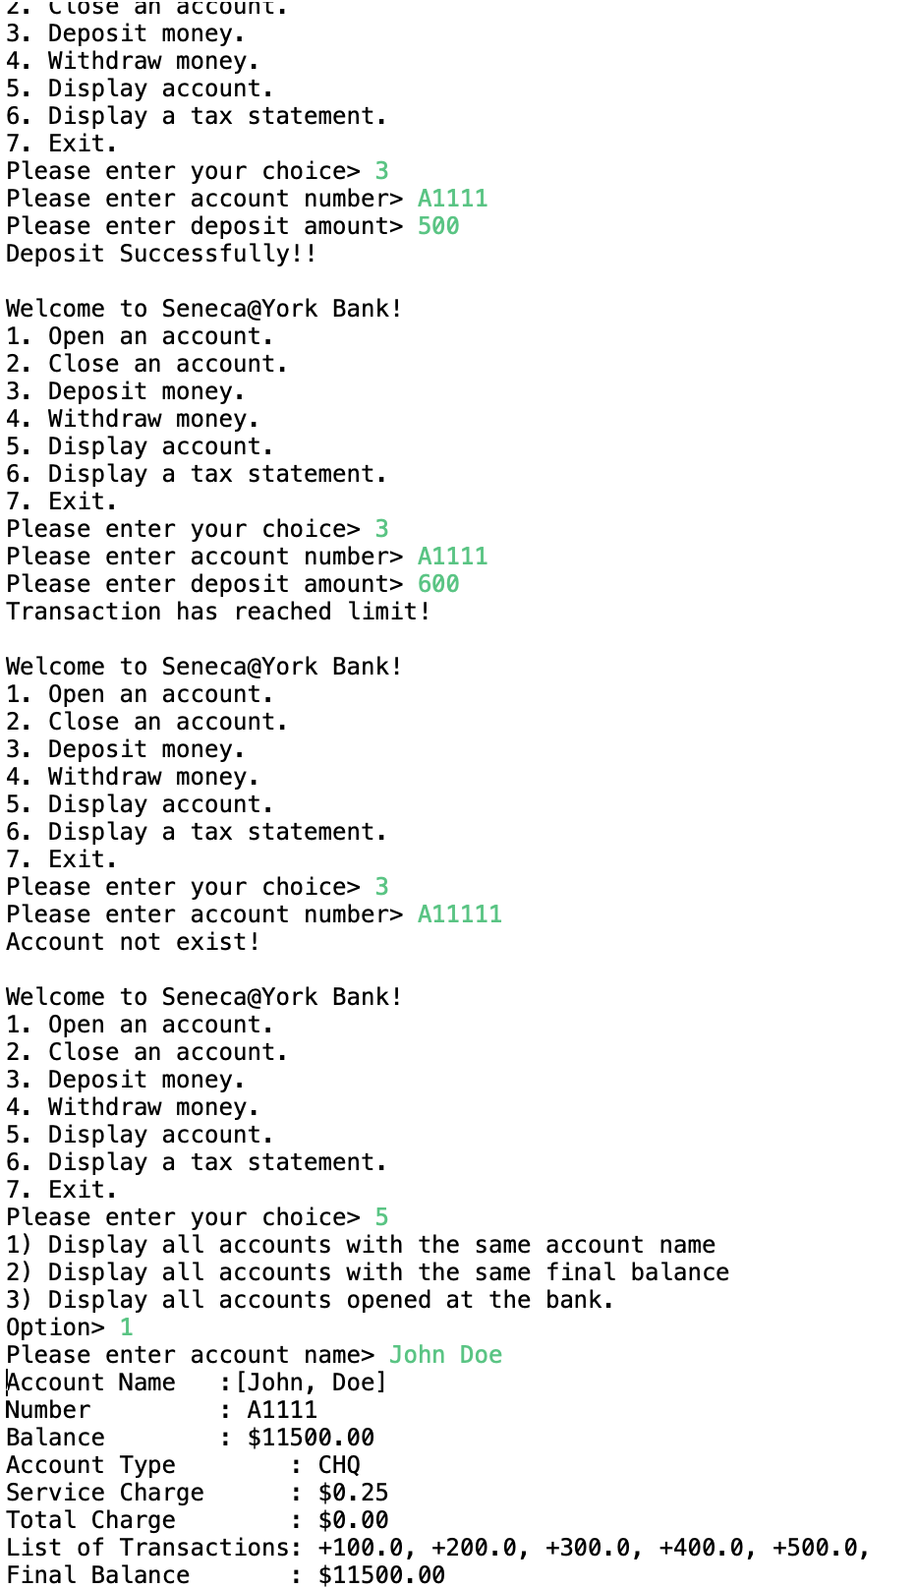

**Case 4: (Withdraw Money) (Starting from 1 -> 2)**

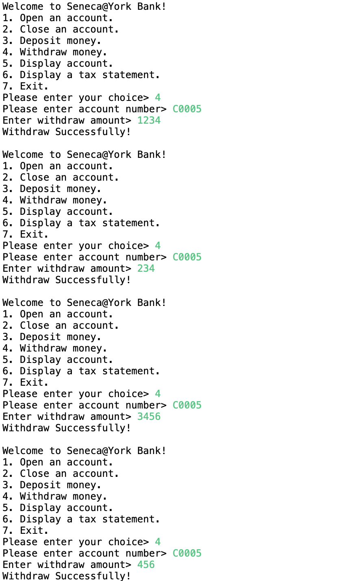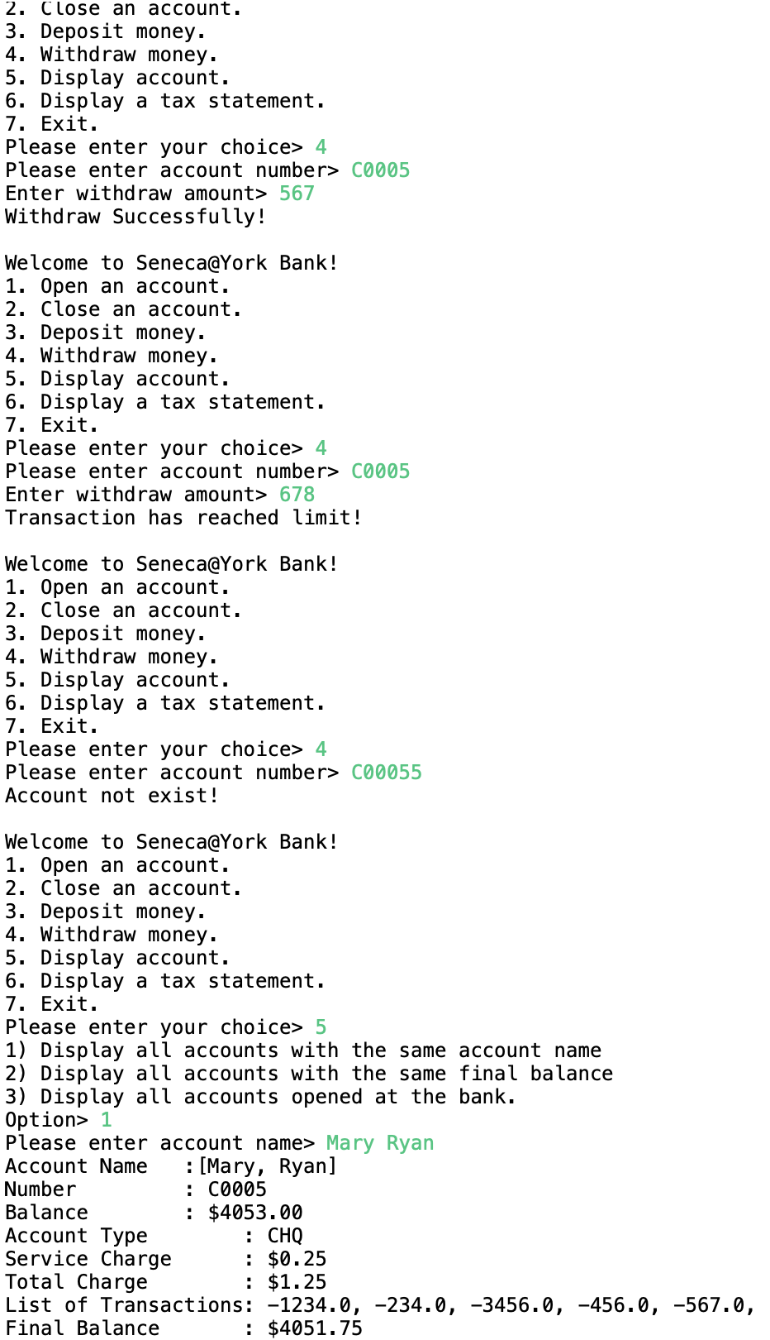

**Case 5: (Display Account) (Starting from 1 -> 2)**

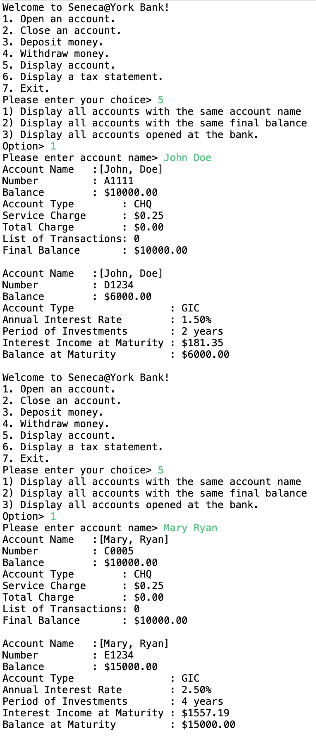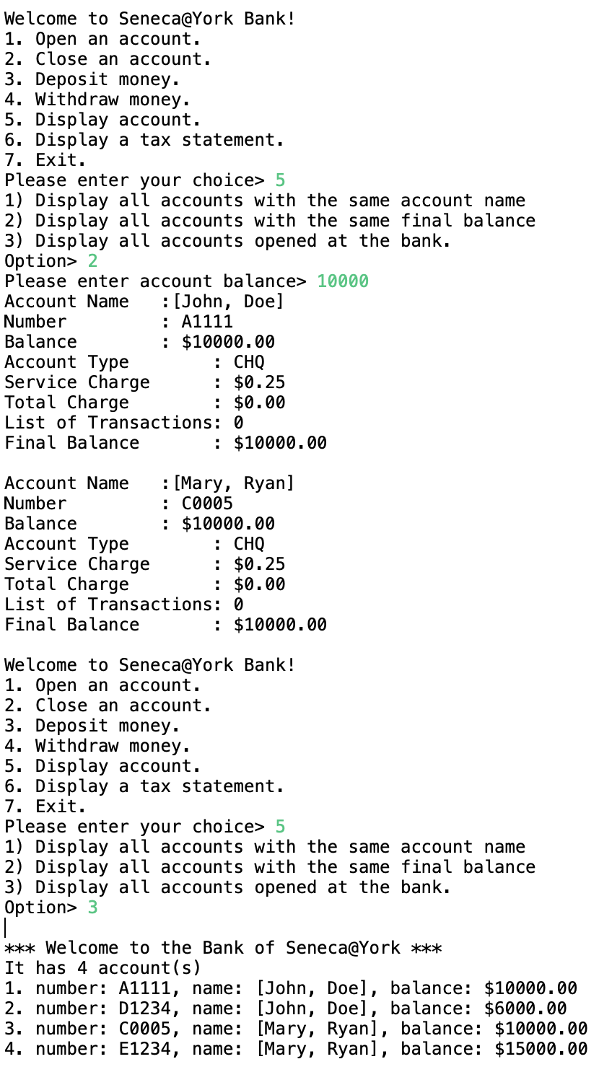

**Case 6: (Display Tax Statement)**

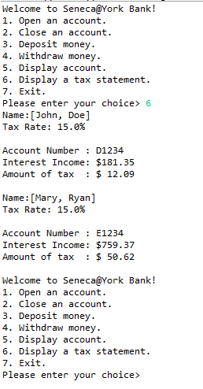

**Case 7: (Exit)**



**Java Suite Test case**

* **Including: test for each Java class (AccountTest, BankTest, ChequingTest and GICTest)**

